**Please rate the usefulness of our training in the following content areas. 1 represents "not at all useful" and 5 represents "extremely useful."**

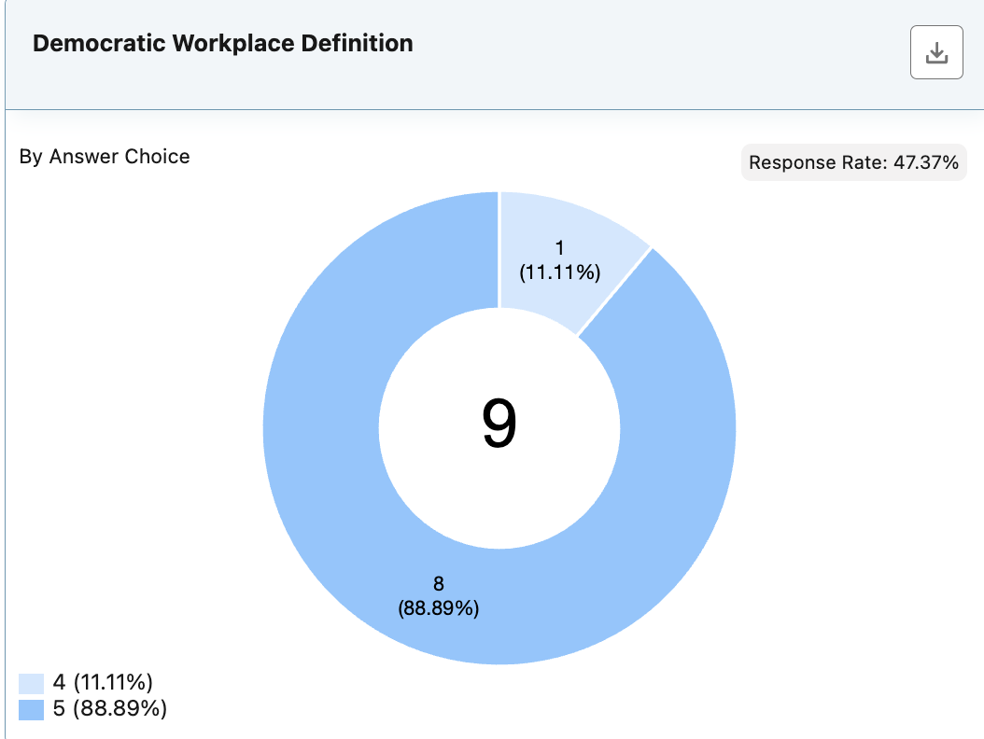

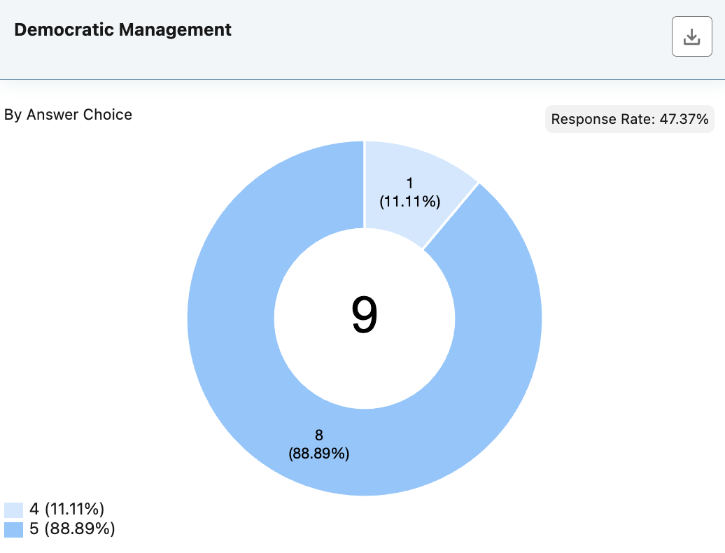

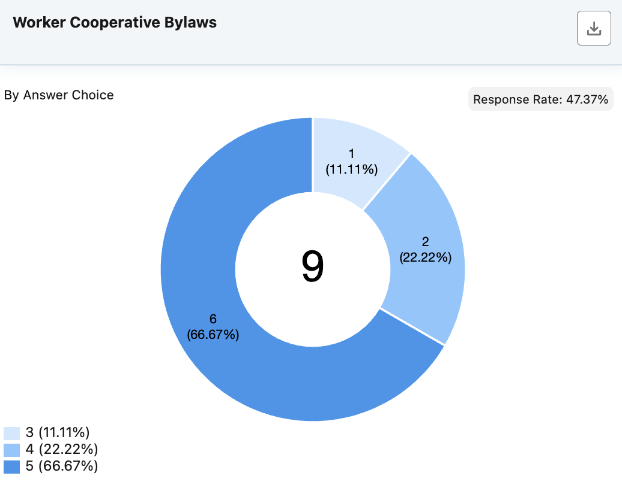

* 5: Good to have examples

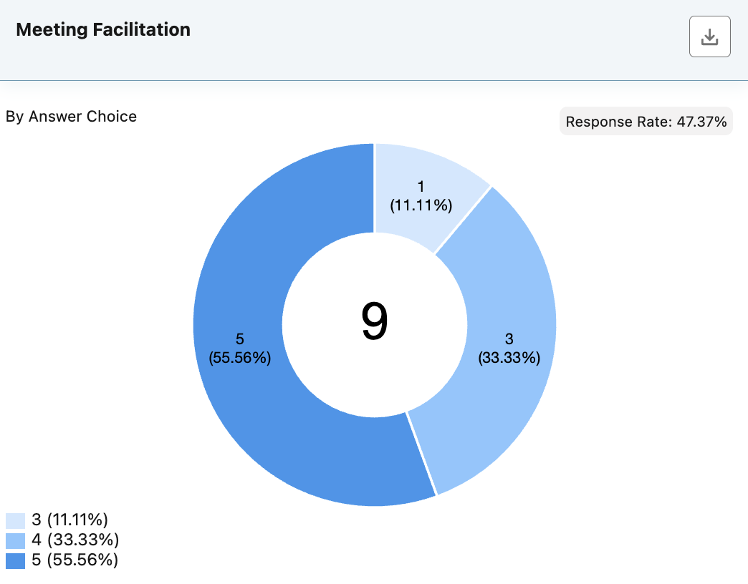

* 3: Good practice for previous training

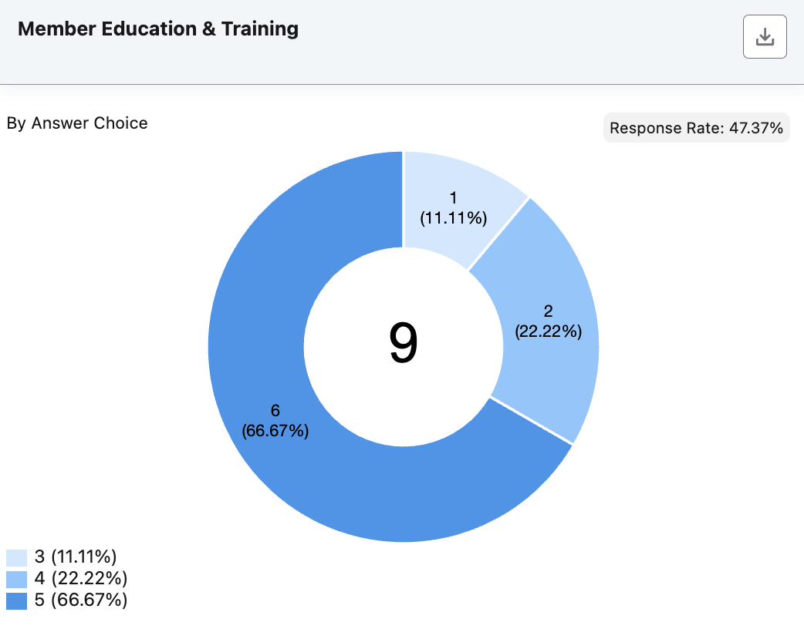

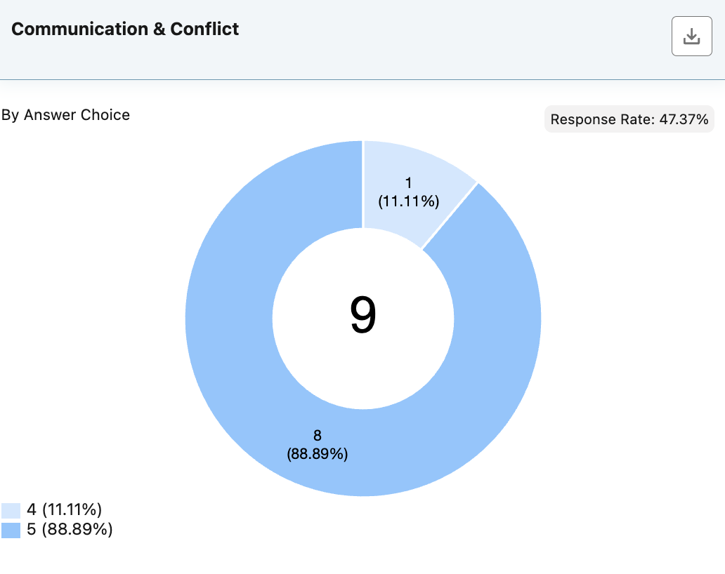

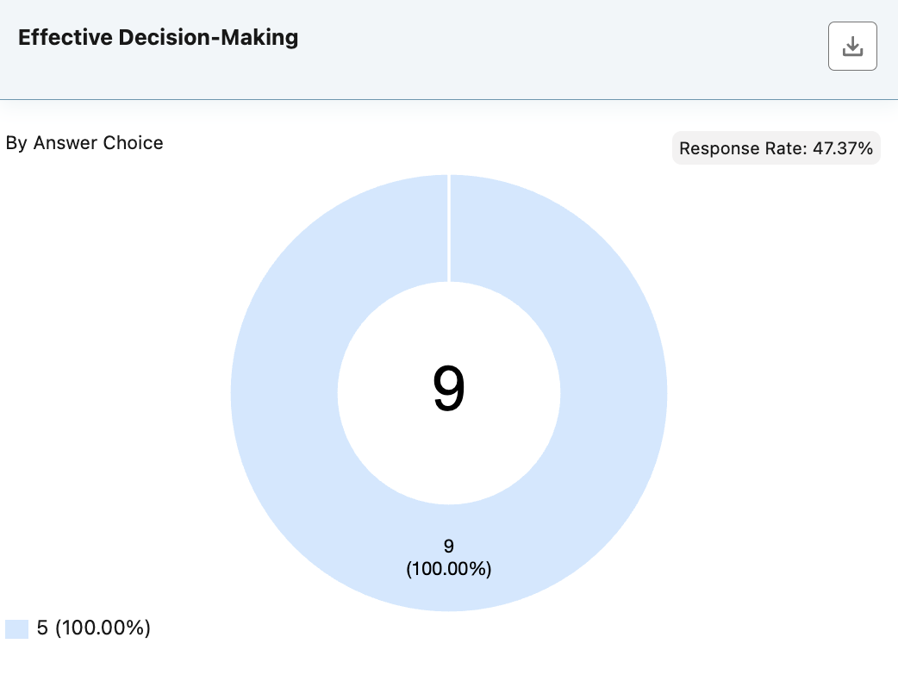

* 5: Good to see one size does not fit all

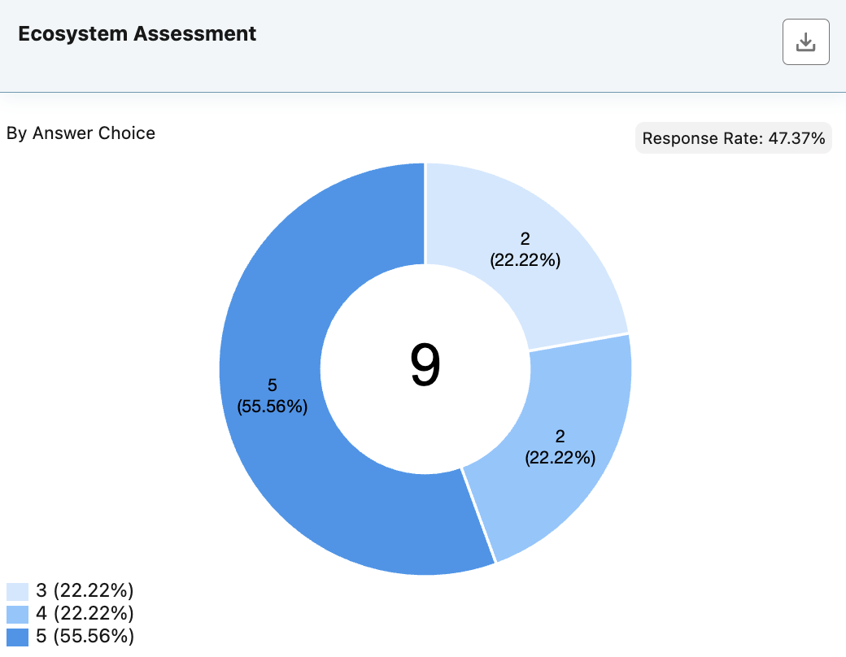

**Please rate the usefulness of the following processes for your work. 1 represents "not at all useful" and 5 represents "extremely useful."**

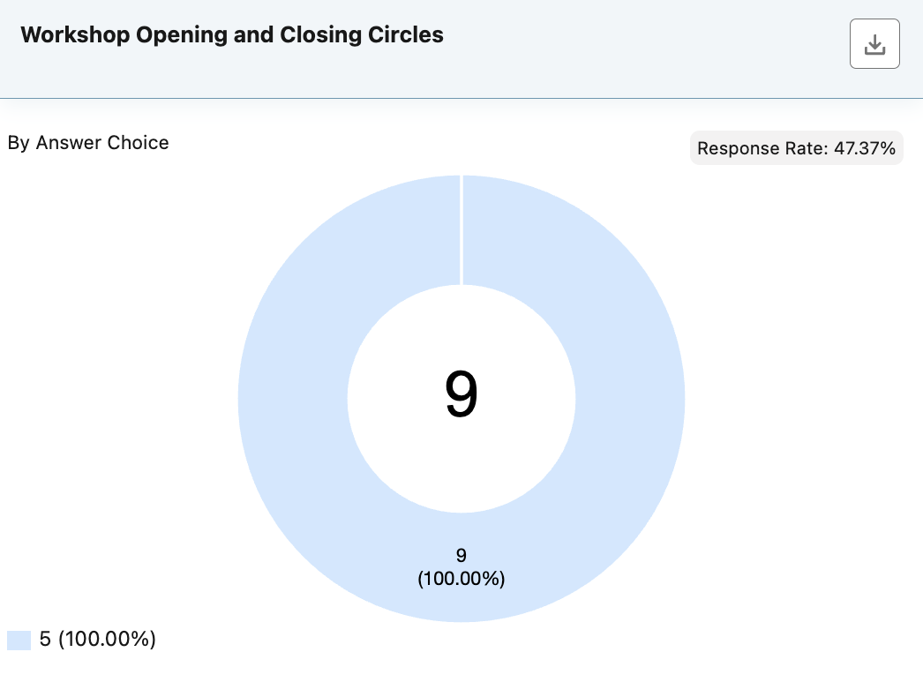

* 5: Good to reinforce and model
* 5: Very helpful to allow for personal engagement and level setting to be mindful in the space

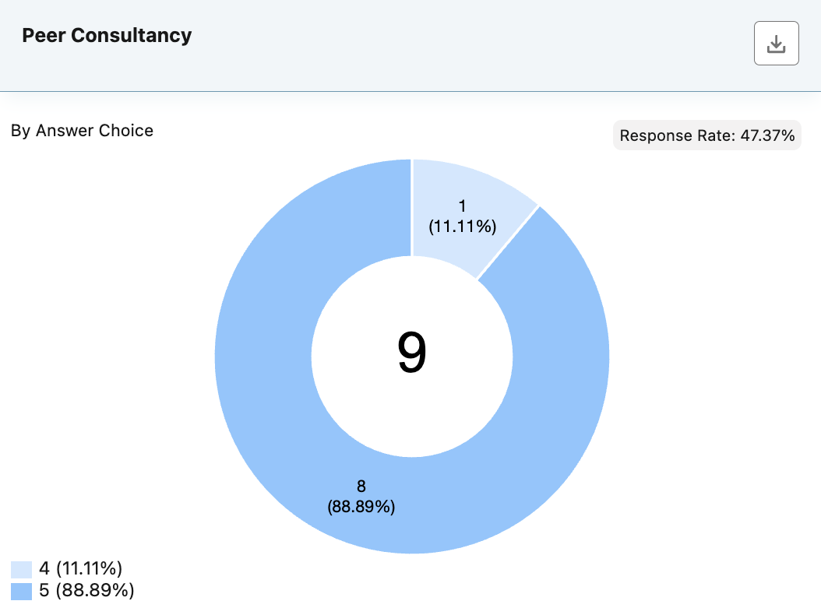

* 5: Very useful method for evaluation skills
* 5: Useful

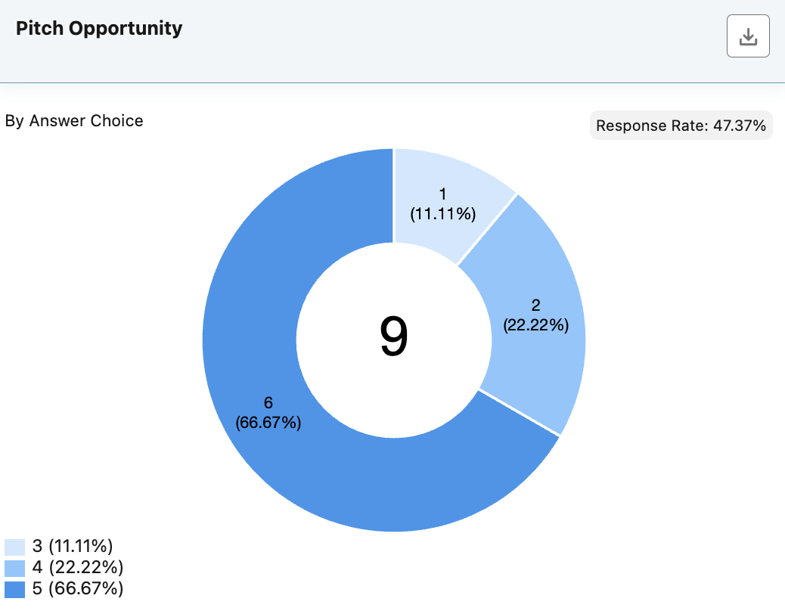

* 5: Good mechanism to get peer feedback
* 4: I Needed more clarity around the use of template versus content for presentation
* 3: Everything else worked out great. The one concrete and most present at top of mind feedback I have is here. I would suggest that you either distribute a template already in Google Slides and forgo the PowerPoint template or at least give someone a heads up if you notice that the conversion process has entirely skewed the text formatting.
* 4: May not be appropriate for this context, but I wonder if we were to do a second pitch building on the feedback received.

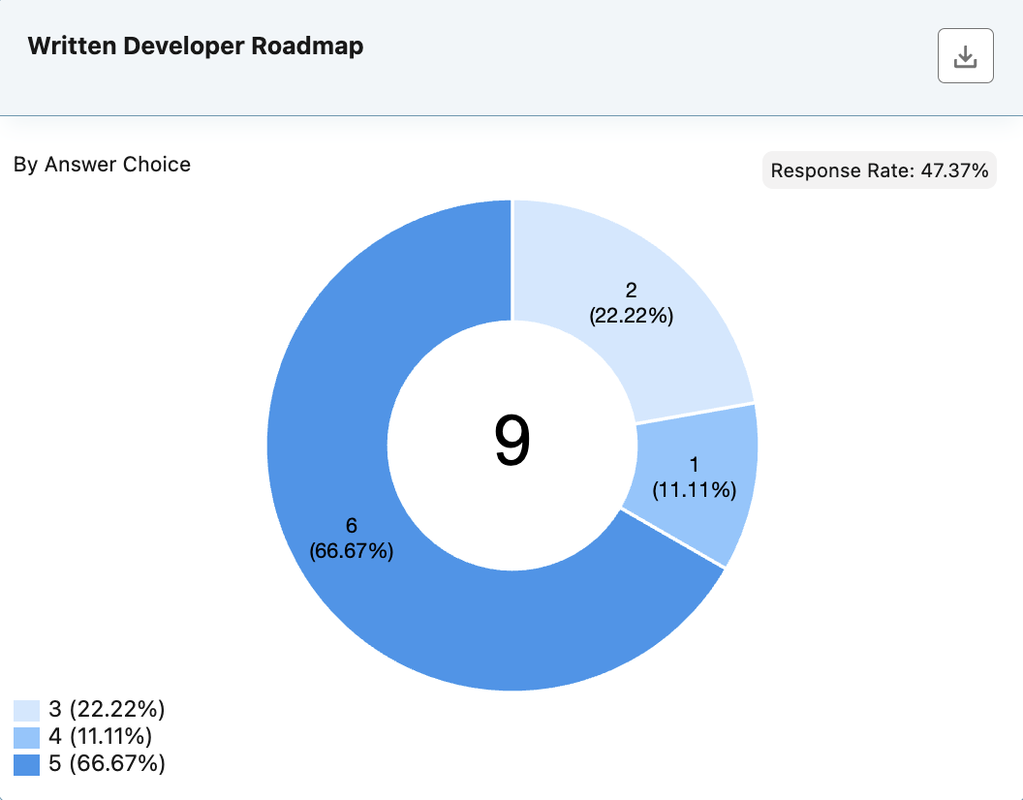

* 4: Helps me with my individual work plan
* 3: Didn't quite fit low touch orgs
* 5: Very helpful for personal accountability and shared ideation

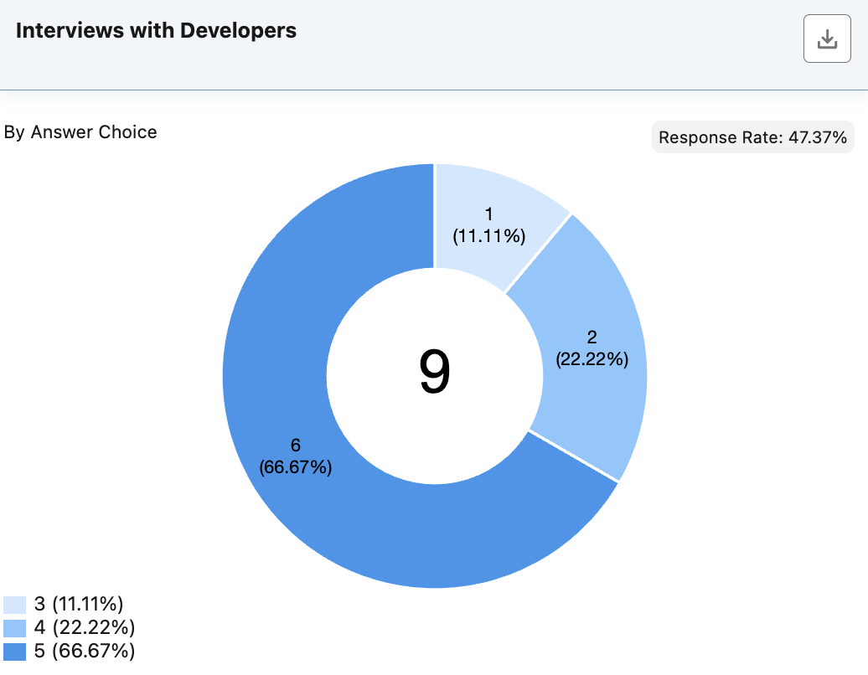

* 3: Craved a bit more targeted conversation relative to Chicago.
* 5: Inspiring

**Finally, please provide your reflections on the following questions based on your overall cohort experience.**



* I can now articulate the unique value proposition and approaches that Kola Community Solutions brings to cooperative development to clients and funders.
* Feel confident that I have the tools, capacity for development and conflict resolution, and facilitation strategies to further this work in Chicago.
* Facilitate trainings on worker-coop development.
* Better understanding on structuring cooperatives, implementing democratic systems within business structures.
* I am now a worker-cooperative developer. It is an official designation and competence.
* Definitely know more about member governance and management that I would like to implement. Better facilitation
* Lean on friends made and DAWI staff.
* Know for certain that we want to add cooperative development as a part of our community wealth building incubation
* Enseñar de una mejor manera y con ejemplos que DAWI nos proveyó. (Teaching in a better way and using examples DAWI has provided)



* The layers of personal challenge that are being experienced by my fellow developers in Chicago.
* The nuanced ways cooperative governance and management can manifest in response to local/organizational context.
* Coop principles, examples of successful worker-coops, nonprofit incubation of coops is common, worker-cooperative development practices
* Business model canvas, drafting bylaws, conflict mediation
* There are many tools and knowledge I've gained.
* Board vs member, business planning, importance of a viable product
* A whole bunch, including how Hi Touch Cooperatives think
* The variety of industries that participate as cooperatives, democratic decision making
* Sobre leyes que rigen a las cooperativas y presupuestos para su funcionamiento. (About laws governing cooperatives and budgets for their operation)



* I now have the ability to have a closer working relationship with Sequane and possibly Uriel. I will also be able to revisit conversations with others in the cohort when we encounter one another at events to see how things are progressing.
* Actually… everyone 🥹
* Julian on technical & coop education, Justice cream on political & coop education, Tekh on conflict resolution & coop education,
* Sequane: Revolution Institute for matter regarding conversion strategies for manufacturing industry and workforce development. Taryn (Earthseed) and Dede (Justice Cream) for education and advocacy. Mike for facilitation, and meeting mediation.
* My cohort and DAWI.
* Definitely the other folks in the space! Hadn’t met or gotten to know most of the people before this. DAWI
* Cohort teammates and DAWI instructors
* My entire cohort and DAWI



* I have stronger relationships in the ecosystem and a means to clearly articulate what I am available to do for or with others in the ecosystem.
* A clear, relational, and material understanding of who does what in our local ecosystem. I better know who to refer and connect here in Chicago, and how to better advocate for everyone to be individually and collectively more successful.
* Empowered me to feel confident in advocating more awareness of worker coops with Black & Brown youth in the city. This cohort has also provided tools and resources that can further allow me to support the first steps in any interested community members.
* Knowledge and tools to take to my community
* A real sense of possibility.
* Better at understanding the map and the nuance of it. What steps to take and all the aspects of development.
* More aware of the possibilities
* Made me more confident in knowing this is a tool that we can utilize
* Un impacto importante en lo personal y profesional. (An important impact both personally and professionally)
* I plan to apply for the Voqal and Echoing Green Fellowship. This has given me a clearly aligned project to employ in both those application processes.
* A deep, patient reminder of the porous boundaries of our organizational work… both the need and availability to collaborate with our national partners.
* Moving forward, we are baking in time to provide ongoing training and education on coops which was lacking previously due to access to consolidated resources to study and facilitate.
* Affirms commitment to community well being and steps to achieve solidarity and economic vitality.
* I now bring a set of critical skills that I can help the staff gain over time.
* I think I have more of a Birds Eye view and can understand our work in the larger context of Chicago. Working through conflict better and better communication.
* Used some techniques in group interaction
* Lots, it's made me mentally feel more aligned with cooperatives and how close i've already been to the work from a value perspective
* Tener más trabajo. Haha, bueno de alguna manera tengo una responsabilidad más amplia con respecto a algunas cooperativas y tengo la libertad de guiarlas con todo el material y aprendizaje que he obtenido de DAWI. (Having more work. Haha, well in some ways I have a broader responsibility with respect to some cooperatives and I have the freedom to guide them with all the material and learning I have obtained from DAWI)
* No, everything has been so intentionally planned. You all did a great job. Thank you!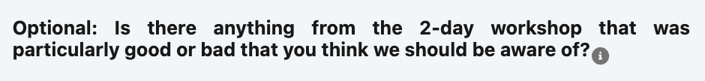
* Sometimes a little long. Outside time was always helpful.
* Good grounding exercises
* The acknowledgement of humanity and human needs via a variety of accommodations - food, breaks, information sharing - was good
* Everything that was done worked well for me and I would recommend you just continue iterating off of the feedback. I cannot name any additional specific needs that I had of the cohort.
* Honestly I don’t think I have feedback here! I know this Chicago cohort thrives with high touch, collaborative support so maybe more of that — but that may not be applicable in other contexts, nor possible in this container for resource constraints etc.
* As a community organizer and urban farmer, the timing of the cohort in the spring and summer presented some scheduling conflicts that I didn’t foresee. It has me at the point of excitement for November & December to dive deeper. I wonder if there is a way to play with a 9-month commitment July-March (that considers the December/January holiday season as a slow time for folks to study/dive into assignment outside of traditional “work hours”. I often found myself having to choose the urgent need to “put out fires” over fully participating in some of the webinars. I will be utilizing November to review and present what I’ve missed/learned and in early December will work to collectively incorporate the lessons from this cohort— this is a reaction to April-July being absolute mayhem as the growing /summer event season began.
* I still think shortening the workshops will help. Perhaps going from 9am- 3:30pm.
* It’s a bit of a long program but not sure how to make it shorter. The July and August webinars were kind of hard to remember what happened. So maybe switching up the curriculum toward the end or something.
* Continue mix of guest speakers and informal dinners. Have a blank flip chart page or whiteboard at all times to capture random thoughts and announcements
* Source restaurant recommendations from participants, Maybe onsite neighborhood visits to provide additional context for community and place based approaches
* Creo que la enseñanza fue muy buena, la interacción en mi lengua principal fue un plus. El lugar y que proveyeron aperitivos y alimentos fue también muy bueno. Lo que recomiendo sería que aparte de lo teórico pudiéramos verlo en la práctica. Poder visitar algunas cooperativas y vivir esa experiencia de estar en el lugar. (I think the teaching was very good, the interaction in my principal language was a plus. The location and the fact that you provided snacks and food was also very good. What I recommend would be that apart from the theoretical part, we could see it in practice. Being able to visit some cooperatives and live that experience of being there)