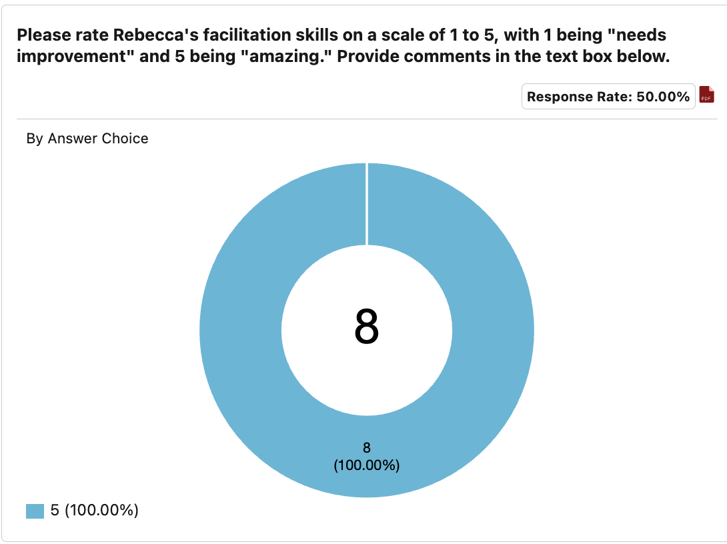

* 5: Excelente
* 5: Gracias!
* 5: I deeply appreciated all of the community building and circle work that was invited into this particular session. Rebecca was gentle in the offering and they met the need of helping us build familiarity.
* 5: Rebecca is amazing

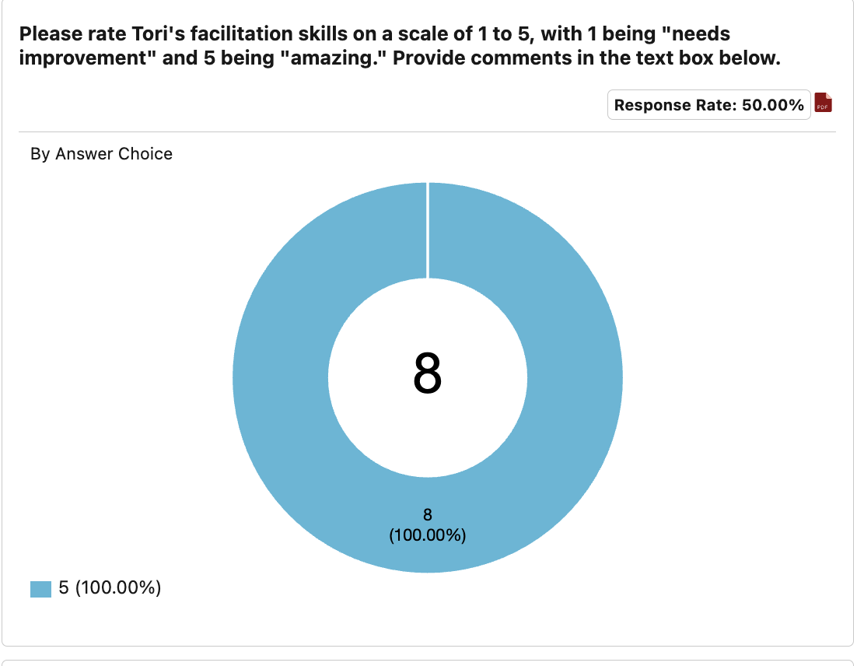

* 5: Genial (Terrific)
* 5: Gracias!
* 5: Tori was clear and helpful in grounding both the theoretical and specific dimensions of the material in a way that I think everyone could relate to well.
* 5: Tori is fantastic !
* 5: Extraordinaria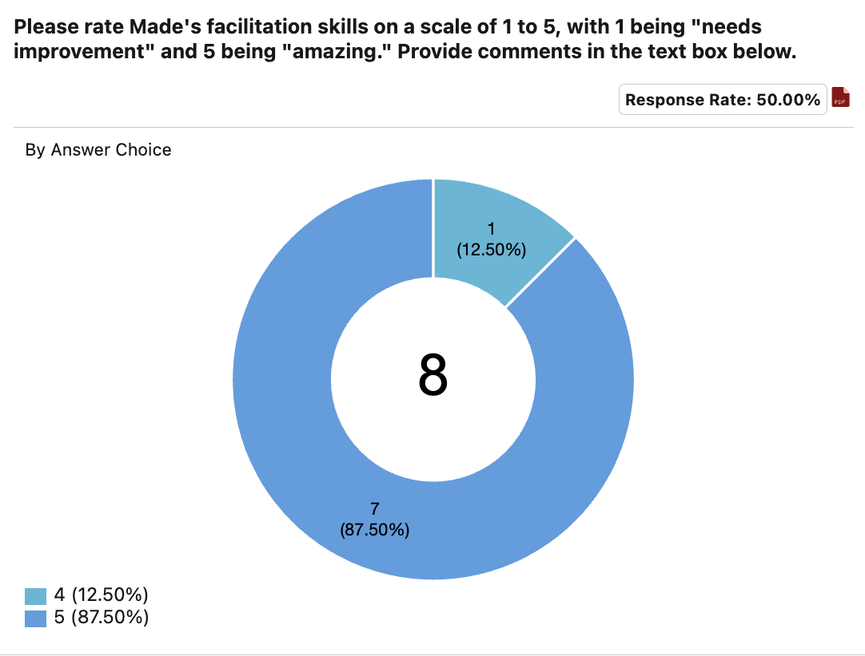
* 5: Gracias! Por alguna razón está más fresca la información que recibo en Español (Thank you! For some reason the information I receive in Spanish is fresher)
* 5: I appreciated Made’s exploration of the different topics and want to encourage her to lean confidently into the things she is saying. Invite the audience into the discourse even if it is in conflict with what is being presented.
* 5: Made es fantástica

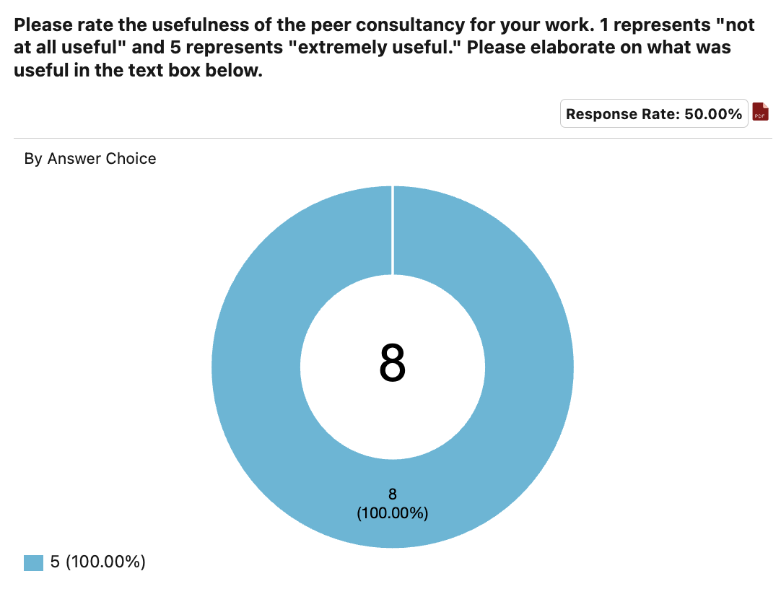

* 5: Valuable Experience
* 5: Me siento contenta de conocer a mis compañeres y me siento menos sola (I feel happy getting to know my peers and I feel less alone)
* 5: I always appreciate the new learnings I derive from this process.
* 5: I love the different perspectives. It’s a practice that we should continue.
* 5: My favorite area of learning and work. I did not locate new territory, but it was great to be in dialogue with others around the subject matter.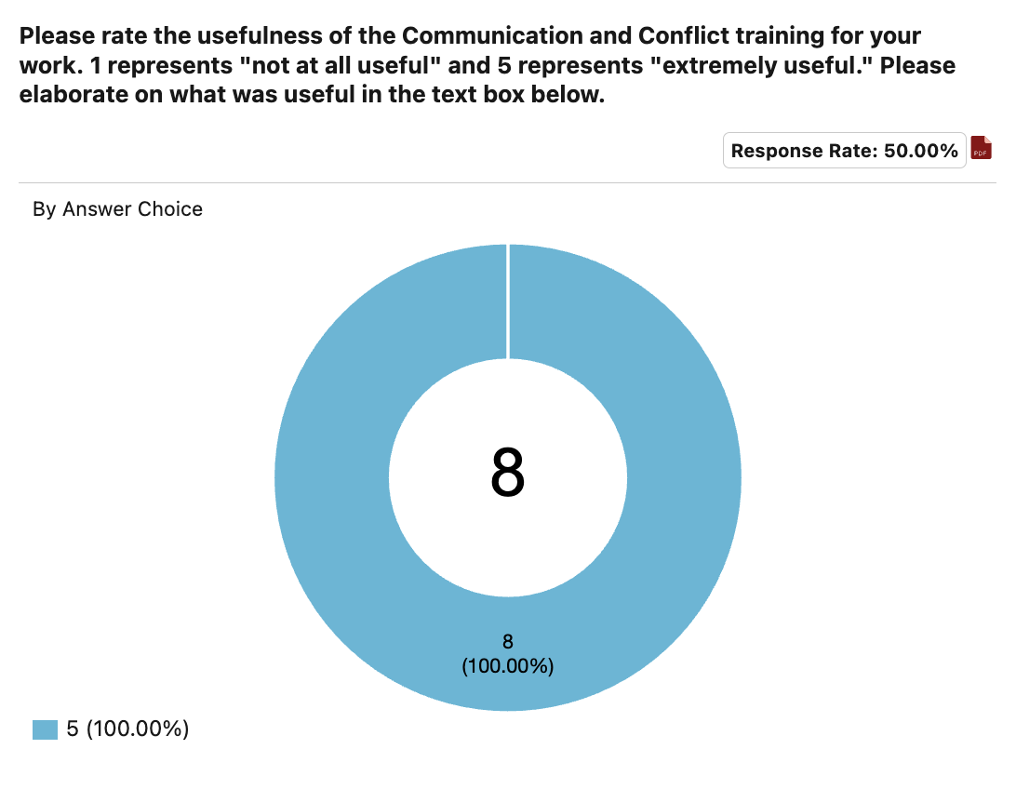
* 5: Gracias Made!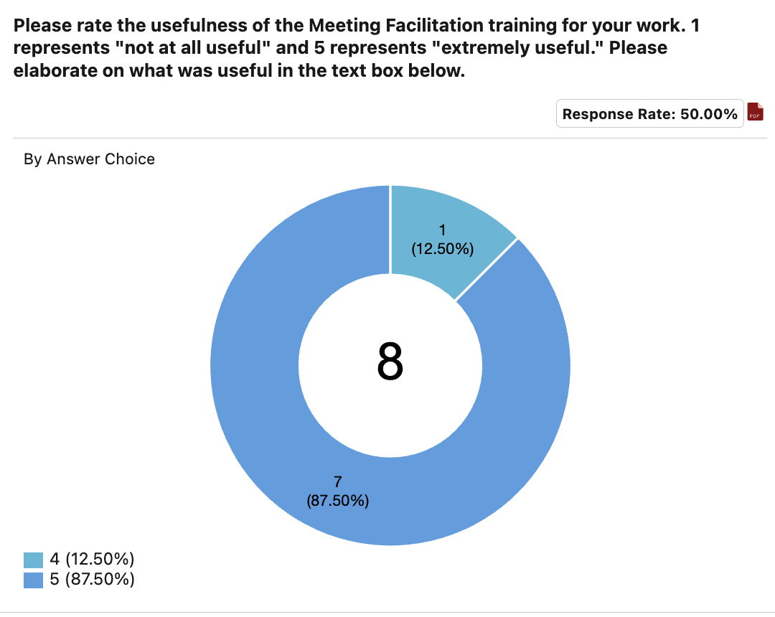
* 5: Good conversation and dialogue about power dynamics.
* 5: I did not utilize interpretation since I am bilingual. Great for accessibility.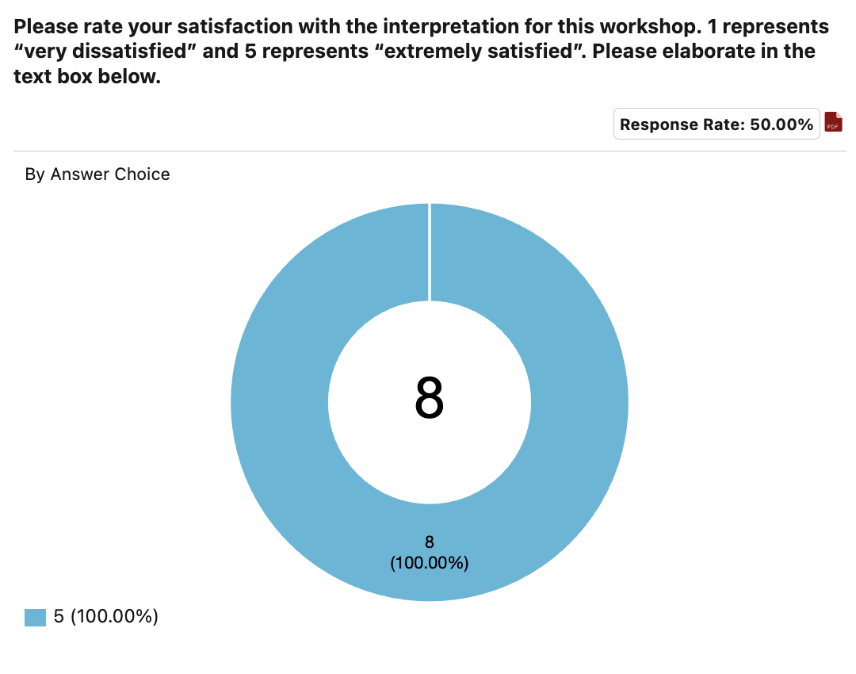
* 5: Killed it! Thanks for your commitment to language justice
* 5: Agradezco que se ofrezca interpretación porque esto facilita y me da acceso a mas información. GRACIAS! (I am grateful that interpretation is offered because this gives me access to more information. THANK YOU!)
* 5: Very gentle voices and they took care to be aware which ear I preferred.

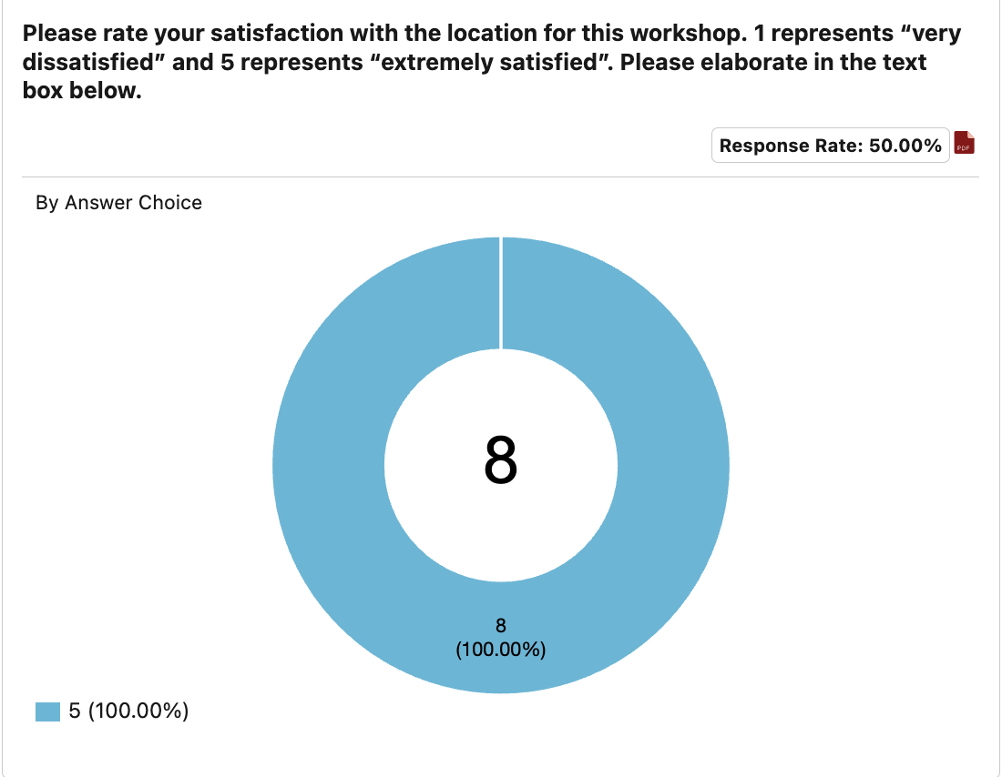

* 5: Accessible y el estacionamiento estuvo muy bien (accessible and the parking was very good)
* 5: Free or Validated parking would be great, ease of accessibility is perfect

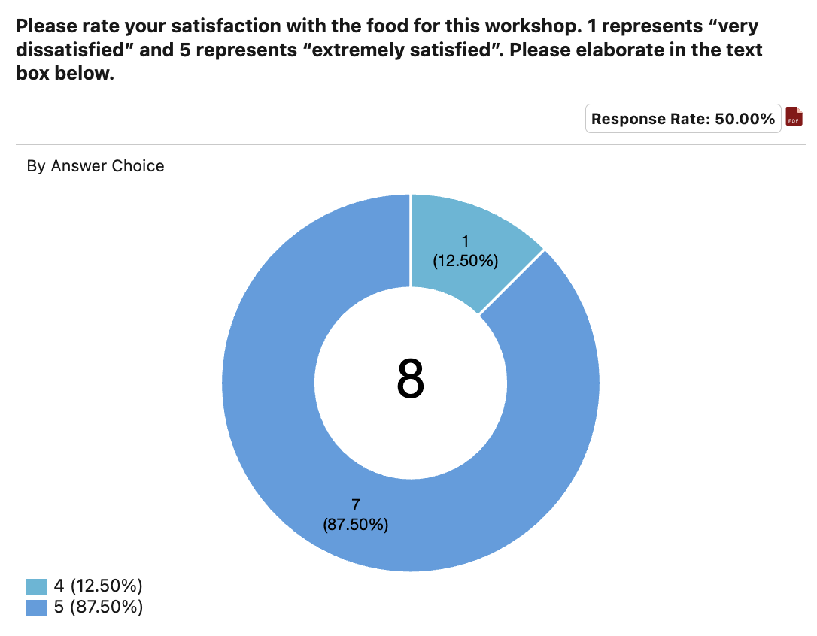

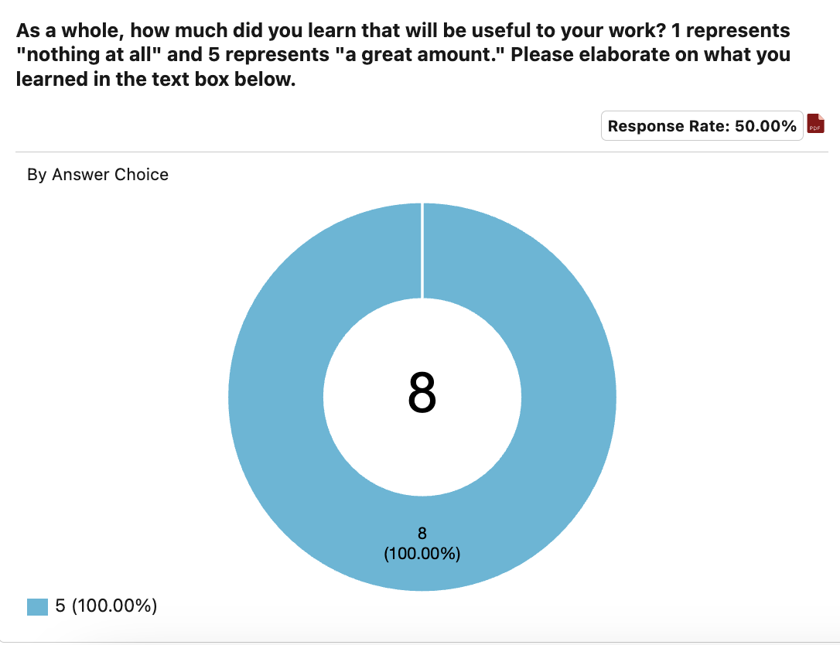

* 5: Super grateful!!! Gaining some much insight and access to resources that I look forward to studying over the years.
* 5: Mucho!!!
* 5: I am very grateful.



* N/A process was efficient and beneficial
* Shorten by one hour
* I know it’s difficult because we are squeezing time but consider 9:30 start time to avoid the city wide hustle to be at work @ 9a
* Probablemente un poco más de aire fresco. (Probably a bit more fresh air)
* A veces el dia se siente pesado. La información muy util pero mi cuerpo ya no aguanta (Sometimes the day feels too full. The information is very useful but my body can’t take any more)
* Outside, weather permitting. Thanks for the flexibility in the workshop in modifying program delivery. Thank you for accommodating everything in real time
* I am sure you all will figure something out, but this is already well beyond my 2018 experience. (Mike)
* I would love a course on grant writing.